**US02 – Team member overview**

## **Short description**

**In order to** indicate that I had a monthly conversation with my PM

**As a** team member

**I want to** be able to have a clickable overview of conversations for this calendar year

## **Detailed description**

This story consists of three main parts:

1. show a ‘stampcard’ which includes the following 16 ‘conversation moments (all on one line)’:
   1. One every month
   2. One every quarter
2. the ability to click on a conversation moment to indicate that a conversation has taken place
   1. To ensure that no moment is accidentally added, we want to allow the user to click on a moment again to restore it to ‘no moment took place’
3. conversations should be saved: I should be able to see if past conversations have taken place

## **Mockups**

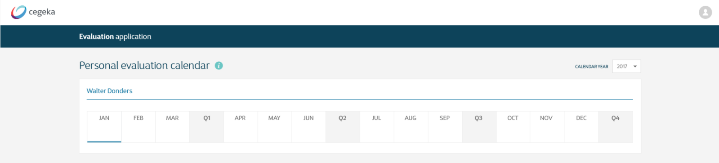

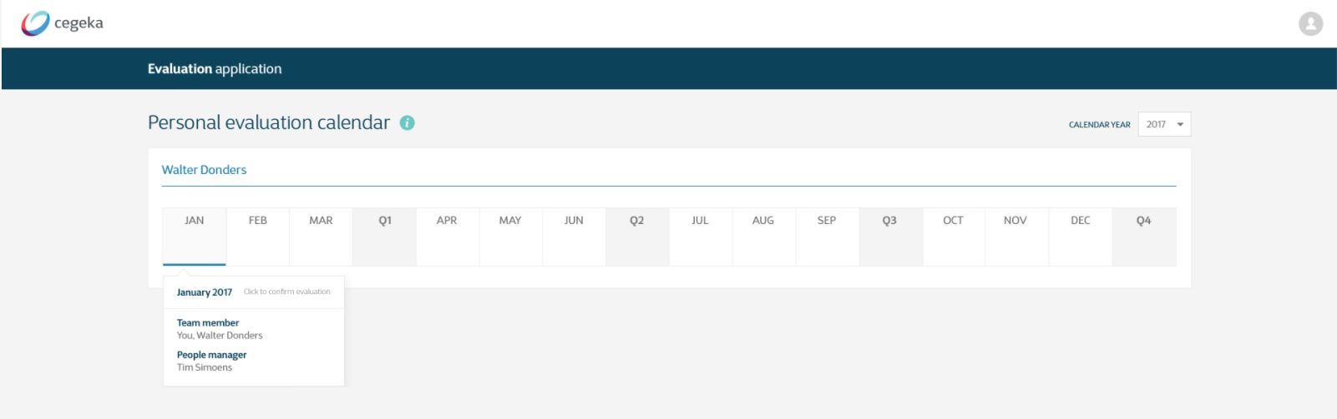

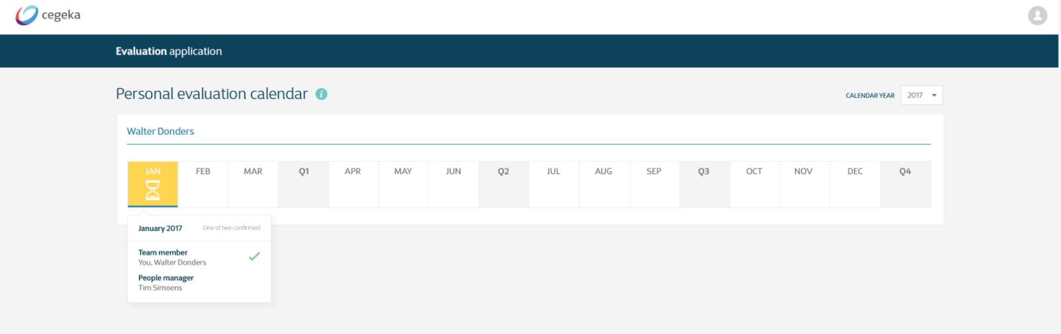

## **Technical description**

## **Acceptance criteria**

|  |  |  |
| --- | --- | --- |
| **Given** | **When** | **Then** |
| I am logged in to the  application | I open the overview page | I see a list of all ‘conversation moments’ of this year: every month + 4 quarters. |
| The list of moments is opened | I click on a ‘month button’ that doesn’t have a moment added to it. | The button turns yellow and the symbol used is ‘...’ to show that one person has indicated that a moment has taken place (See [US 05](https://docs.google.com/document/d/1lAFfW-Pwmuzdy1BtblSqp5D8BtJUvMNtqmfvejf-zMY/edit) to have an overview of all scenarios regarding colors/symbols) |
| I have added a conversation moment and confirmed it (in the window) | I refresh the page | The moment is still visible in the overview |
| The list of moments is opened | I click on a ‘month button’ that does already have a moment added to it | The button turns grey again, without a symbol added, to show that no moment has taken place |